Project execution:

Scoop Injection:

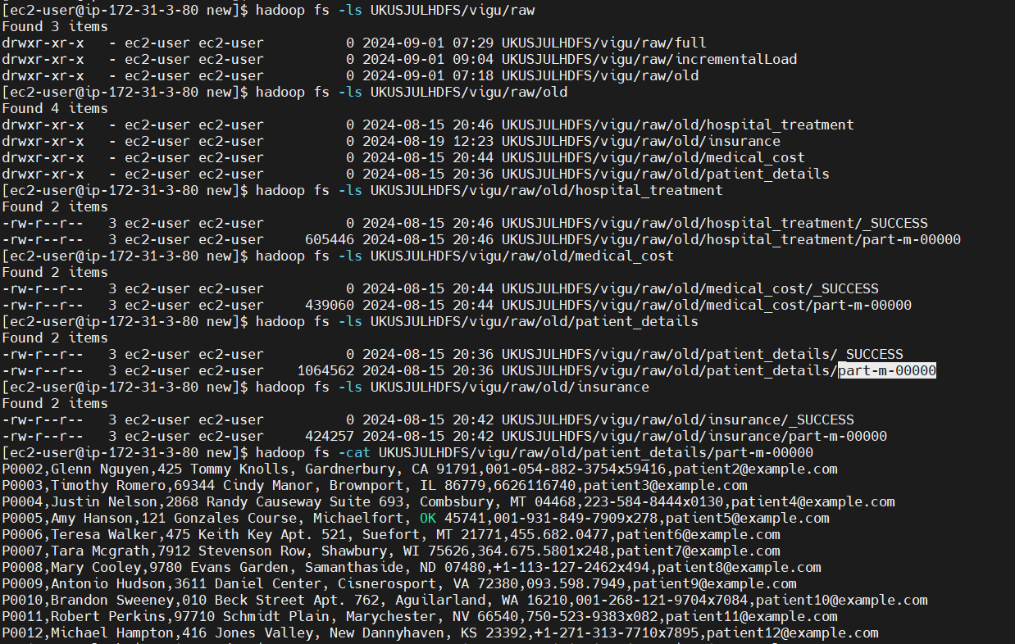

Full load:

Created folder structure:

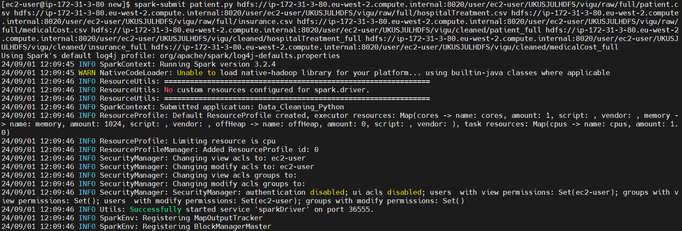

Data generated in respective directories

Data in the file:

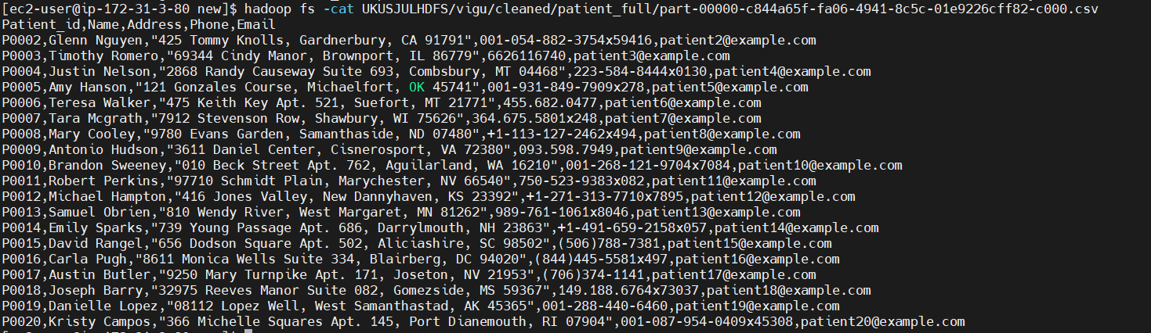

hospitalTreatment:

Insurance data:

medicalCost:

IncrementalLoad:

Raw Data:

Execution:

IncrementalLoad of insurance data:

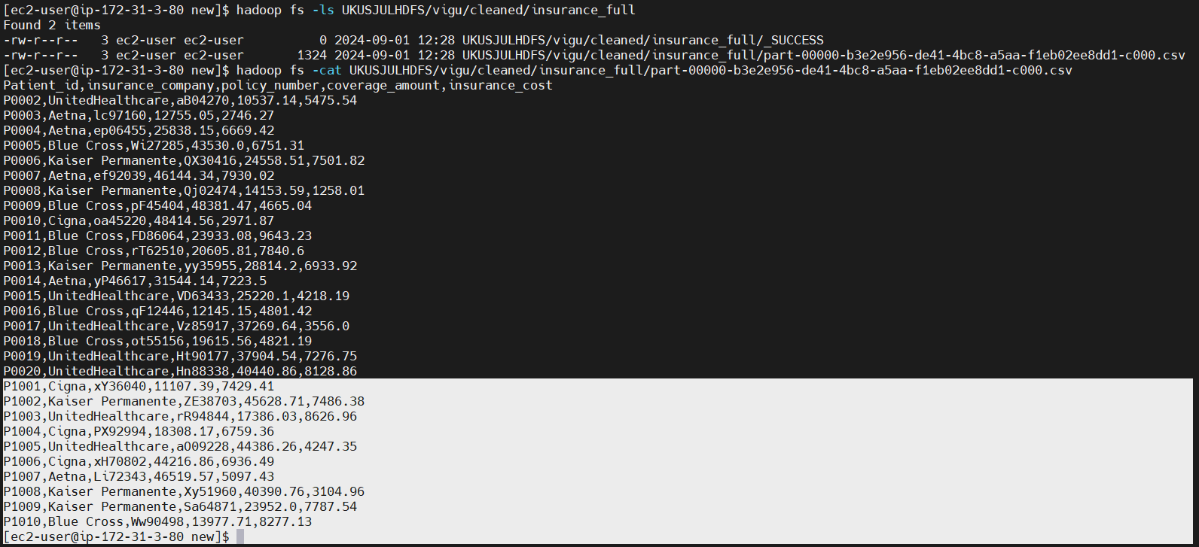

Medical cost:

Patient details:

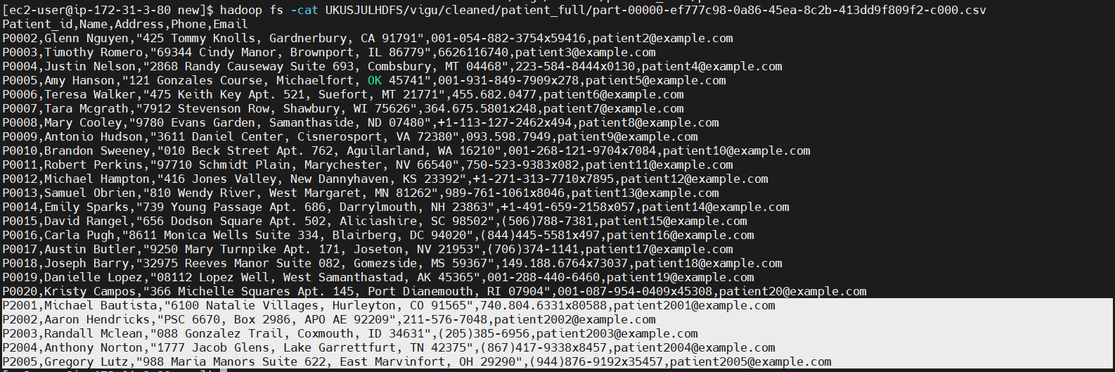

hospitalTreatment:

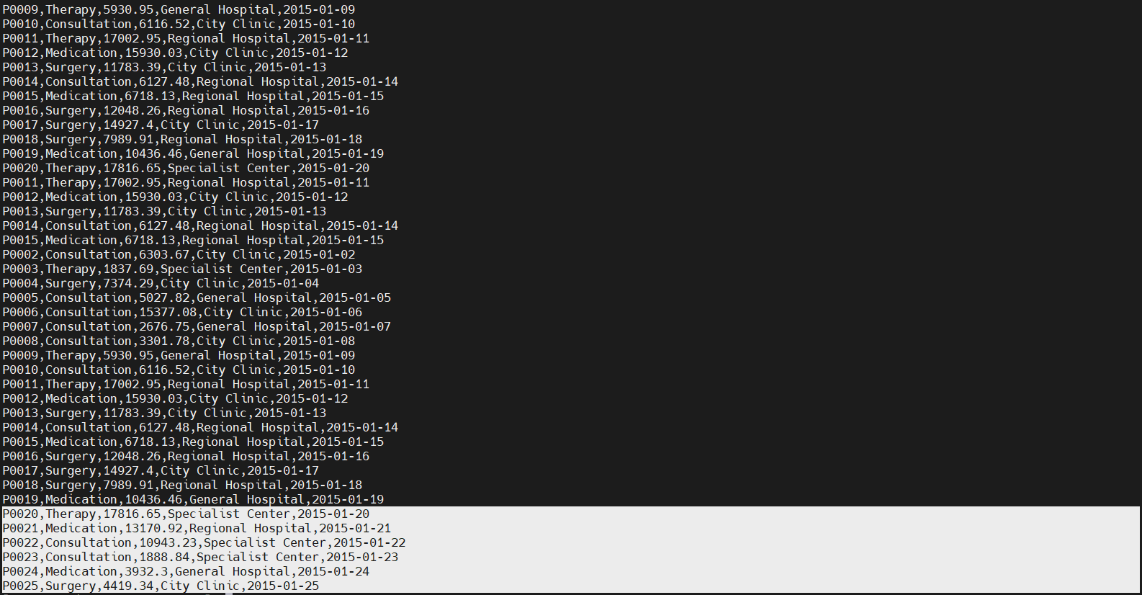

Full load using Jenkins:

Kafka:

Producer:

consumer:

